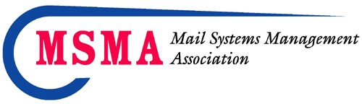
FOR IMMEDIATE RELEASE - PRESS RELEASE

Contact: Floyd Creecy, CMDSM, MDC,OSPC
MSMA Executive Director
Mail Systems Management Association
msma@msmanational.org

November 2021

Oak Brook, IL – The CMDSM Virtual Exam was administered on November 5th
The MSMA Board of Directors is pleased to announce the newest certified individuals:
CMDSM
Catherine Aubrey, CMDSM, MDC – DHS
Michael Carr,CMDSM,MDC – The Millenium Group
Raymond Holmes, CMDSM, MDC – The Millenium Group
Rogel Lima, CMDSM, MDC – The Millenium Group
George Mwago, CMDSM, MDC – The Millenium Group

Congratulations to all these individuals!

For complete program details on the MSMA/AOSP Certifications please visit our website: www.msmanational.org

Anyone wanting more information about certification or membership may contact MSMA through their website www.msmanational.org or via e-mail: msma@msmanational.org

