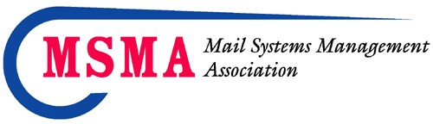
FOR IMMEDIATE RELEASE - PRESS RELEASE

Contact: Floyd Creecy, CMDSM, MDC,OSPC
National Executive Director
Mail Systems Management Association
E-mail: msma@msmanational.org

November 2021

Oak Brook, IL - The Mail Systems Management Association (MSMA) Board of Directors is pleased to announce the recipients of the 2020/2021 MSMA National Awards, which were presented on November 15th during the Virtual Education and Awards Program
Distinguished Service Award 2020 – Mark Hale, CMDSS, CMDSM, MDC, OSPC
Distinguished Service Award 2021 – Denise Streit, MDC, OSPC
Office Service Center of the Year – Gold Recipient – Society Insurance
Office Service Center of the Year - Silver Recipient – The Millenium Group #27500
Office Service Center of the Year – Bronze Recipient – The Millenium Group Hara Azzara Manager
The National Board respectfully acknowledges all the members who participated in this year’s program and encourages members to submit their applications in the future for these prestigious Awards programs.
For complete program details and to review what the awards provide please visit our website: www.msmanational.org

The Mail Systems Management Association has local Chapters in Metro DC and Chicago, and members at large throughout the country. Anyone wanting more information about certification or membership may contact MSMA through their website www.msmanational.org.

