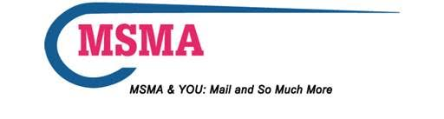
MSMA Keeping You Informed
MTAC Update
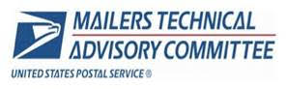
Quarterly MTAC Reports - June 2018

MSMA is one of fifty-eight member associations that have representation on the Mailers Technical Advisory Council (MTAC). On a quarterly basis, representatives from these associations meet with senior postal officials to discuss current and future programs, processes and other issues that affect all mailers. Between these quarterly meetings, there are a number of work groups that have meetings and conference calls to assist and provide the postal service with their knowledge, expertise and feedback in a variety of service areas to help the postal service understand the view of the mailer.

Why is this important to you? There are many matters and issues that are discussed at postal headquarters daily that will affect you, your operation and your budget. In addition the postal service occasionally requested associations to send surveys out to their membership soliciting feedback. It's important that your voice is heard and your mailing issues brought to the attention to the highest levels of postal management.

To review the June 2018 Quarterly MTAC reports click: MTAC June 2018 Reports

Presentations and Membership Assembly/Focus Group notes from the June 2018 MTAC meeting are available for your review on PostalPro via - Postalpro.usps.com/mtac.

We will continue to provide you with updates and information as it become available and/or necessary. We hope you find this information useful and would appreciate any comments.

Please feel free to contact me bfahy@msmanational.org or one of your four representatives below with any questions or feedback.

1. Ron Goglia at ron.goglia@cigna.com
2. Lance Humphries at ljhumphries@msn.com
3. Arlene Zisow at azisow@royalalliances.com
4. Bill Burmeister at bburmeister@dvd.com

Barbara Fahy, MDC
MSMA National President
bfahy@msmanational.org
1-800-714-MSMA

National Headquarters
PO Box 1145
N. Riverside, IL. 60546-1145
Website: www.msmanational.org
Phone: 1-800-714-MSMA

